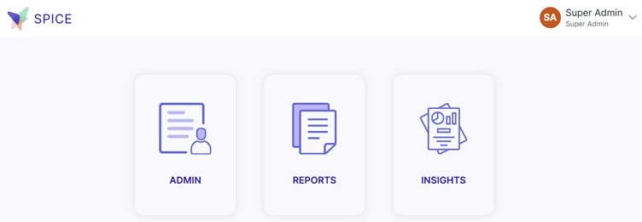
1. Admin Tab: This section is usually for managing users, settings, and system configurations.
Common actions include:
- Adding or removing users
- Changing user roles/permissions
- Updating system settings
- Managing security and access controls
2. Reports Tab: This is where you can generate, view, and download reports.
Typical functionalities:
- Viewing pre-built reports
- Customizing reports with filters
- Exporting reports (e.g., CSV, PDF)
- Scheduling automatic report generation
3. Insights Tab: This section provides analytics and visual dashboards to help you understand trends and performance.
Key features might include:
- Interactive charts and graphs
- KPIs and performance metrics
- Predictive analytics
- Data exploration tools

